Azure devops

3-19 —Introduction
azure devops - azure is cloud service provider which is provided by micro soft
devops - dev is to automation of code using power shell or python , ops is to support project( like monitoring , maintenance , etc…)

subscription - collection of RG’s , mainly used for costing
resource groups - collection resources
resource -
power shell is supported by micro soft
azure provides different types of platforms
IAAS - infrastructure is used (creating vm, storage , n/w etc). only infrastructure is provided by micro soft .maintenance is done by ourself
PAAS - .net , python kind of frameworks provided (deploy applications like web apps). maintenance is done by micro soft
SAAS - using application with out installing. eg- office365
solution design document provided by architect
no. of resource groups or resources can be created under one subscription can be defined by subscription policy (diamond , gold silver etc)

why azure
1)Azure has developed ocean containerisation which has more reliability than on land
2)HA
3)high security
4)monitoring
VMSS - based on the usability configuration will be adjusted automatically.

3-22 Storage

1)to store unstructured data
2)to store backup’s
3)to store log info
4)VHD(hard data disk)

ssd - data will be stored in storage account

kind - v1, v2, blob storage

V1 | V2(general purpose v2) | Blob storage
Types - container(blob)  2)file  3)table  4)queue | Types - container(blob)  2)file  3)table  4)queue | container storage
no access type | access tiers - 1)cool(infrequently using data)  2)hot(for data using frequently) | access tiers - 1)cool  2)hot
no | Archieve (able to restore) | Archieve

https://docs.microsoft.com/en-us/azure/storage/common/storage-introduction

Redundancy

https://docs.microsoft.com/en-us/azure/storage/common/storage-redundancy?toc=/azure/storage/blobs/toc.json
1)LRS (local redundant storage) -
2)ZRS (Zone redundant storage)
3)GRS(geo) or GZRS(geo-zone)

Data protection (
1)point in time restore
2)turn on soft delete for blobs(soft delete will be min 7 days and max 365 days)
3)turn on soft delete for containers
4) ,, ,, ,, ,, ,, file shares

tracking - 1)turn on versioning for blobs - historical data of files
2)turn on blob change feed - individual file historical data

Azure cost calculator

3-23 Storage

1)overview — all info regarding resource
2)activity log - logs will be there , to track the all the activities that performed on resource
3) tags and Diagnose and solve problems - tags is identification , we can tag environment, owner ,etc
tags to tag accounts and diagnosis to solve problems regarding resource

4) IAM (identity access management)
useful to give access to subscriptions, resources , users and groups.
mainly used roles are
1)owner - this has full access
2)Contributor - has full access but can’t give access to peers
3) reader - only read option

container (it is collection of files or folders)
it has three different types of blobs in it

1)page blob - VHD(to store hard disk of a vm) — .vhd will create page blob
2)append blob - logs(logs of a resource can be stored)
3)block blob - documents and binary

while creating container there will be options to chose from public access live;

i)private(no anonymous access)
ii)blob(anonymous read access to blob)
iii)container(anonymous read access to blob and containers)

4)Storage explorer - in order to access storage accounts locally without out logging into azure portal
i)through azure account
ii)add resource via azure AD - full control on storage account
iii)connection string - mostly used ——A connection string includes the authorization information required for your application to access data in an Azure Storage account at runtime using Shared Key authorization.
iv)use a shared access signature — mostly used out side users
v)use a storage account name and key
vi)connect to public blob container
vii)attach to a local emulator

5)Data migration
Azure Database Migration Service is a tool that helps you simplify, guide and automate your database migration to Azure. Easily migrate your data, schema and objects from multiple sources to the cloud at scale.
Eg - in order to copy data from vm to azure storage , install the storage explorer in vm and the drag the data into storage explorer

6)Access keys
used to connect to the
account. this can be done by using the following option
1)by connecting through azure portal
2)using keys - alphanumerical value
3)using Connection strings
Server=tcp:myserver.database.windows.net,1433;Database=myDataBase;User ID=mylogin@myserver;Password=myPassword;Trusted_Connection=False;Encrypt=True;MultipleActiveResultSets=True;

combination of storage account name and key —mostly used ——A connection string includes the authorization information required for your application to access data in an Azure Storage account at runtime using Shared Key authorization.
4)using storage credentials

5)SAS(shared access signature) - mostly used out side users
eg - BlobEndpoint=https://storagesample.blob.core.windows.net;
SharedAccessSignature=sv=2015-04-05&sr=b&si=tutorial-policy-635959936145100803&sig=9aCzs76n0E7y5BpEi2GvsSv433BZa22leDOZXX%2BXXIU%3D

7)GEO replication - it shows where the replication is done.
8)CORS - cross origin resource share
CORS is an HTTP feature that enables a web application running under one domain to access resources in another domain.

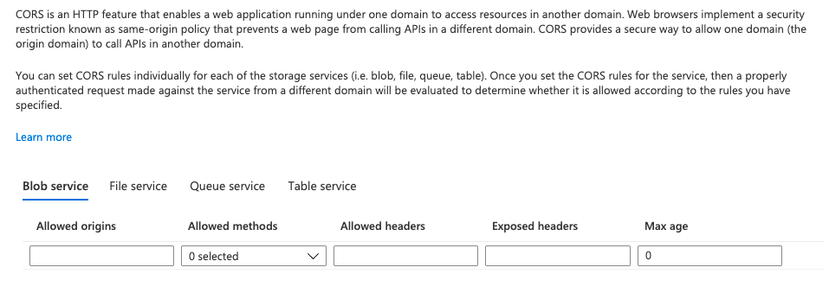

9)configuration - to view or change the parameters set for an storage. except premium or standard option.

10)SAS - Shared access signature

in IAM we give access on storage to with in Domain, to give access to out side the domain we use Shared access signature.
by using following url’s ,storage can reaccessed by the particular ip address

to restrict the data sharing 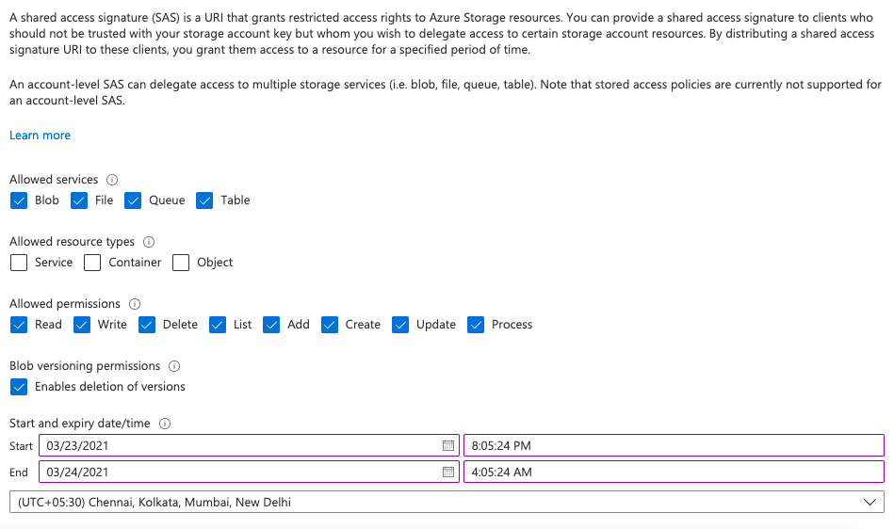outside the azure domain.

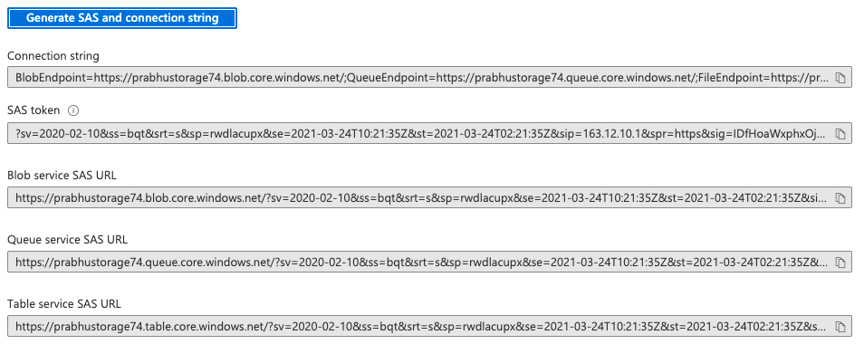

11)networking
1)public access level
2)private access level
for every resource there will be a end point. To establish a connection between the two resources private connection is enabled.
p2p
s2s

12) static web

Naming convention - $web
when we need to use a single fixed content web page instead of multiple webpages static web will be used
it is used to reduce the cost.
how to create static web — 1)create container by naming $web
2)create 2 web pages under $web
i)application html page
ii)error pages
3)go to static website option in stoarge and make enable. give the two
HTML names
When There is no dependency on html page then we go for the static web

13) storages

https://docs.microsoft.com/en-us/azure/storage/common/storage-introduction

14)life cycle management - to make the resource switch to cool mode from hot.(to move to achieve or to make to soft delete when it is not used for certain period)
need to create rule for this

11) azure content delivery network(Azure CDN) - to access the data from the other domains with same speed as the user accessing the data from same domain.

13)LOCKS - lock is for security
i)read only lock
ii)delete lock
this will enable only read only or delete options to user.
user can’t modify till the lock is unlocked

14)PROPERTIES
/subscriptions/ec5d4f46-4521-442f-9e23-2dc6955e77e3/resourceGroups/prabhu-hyd-dev/providers/Microsoft.Storage/storageAccounts/prabhustorage74

15)REPLICATION

https://docs.microsoft.com/en-us/azure/storage/common/storage-redundancy

16)Alerts
i)metric alerts - average , sum , max type of alerts( http 201 , http 4xx more than 10 etc)
ii)general alerts - trigger alert the moment it happened(high cpu utilisation , high memory etc
to monitor the abnormal alerts
Action group - We will configure action group (mail or teams group) , it will notify once the alert got triggered
Alert logic (condition)- average , greater than count , threshold value
when to evaluate
Check every - one min
loopback period - 5 min
here alert will check in every one min for last 5 min of alert rule
17)EVENTS
when something has happened to container that should be known to resource
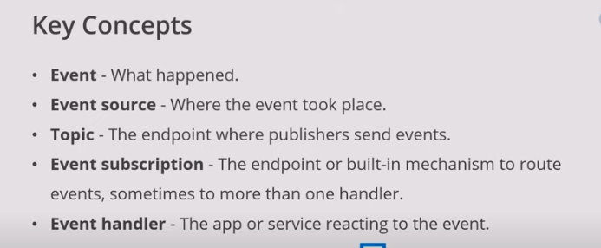

i)event needed to be created is selected under filter to event types option.
ii)resource url is given in end point.
METRIC Alerts
based on the avg of errors or failures then the alerts will trigger
Advisor
it will send the advice message when something is recommended.
eg—> if we set the advice on storage to show the alert when the storage is 80 percent is full. it will advice that storage is almost full please extend the drive.

resource health check - to check the resource heath

connectivity check - connectivity check

recovery deleted account - to roll back deleted accounts

containers - to store VHD , files and logs

File share - to establish connection between local system and azure (to drag and drop files or data from local to azure) for this port 445 must be opened by network service provider

create event subscription
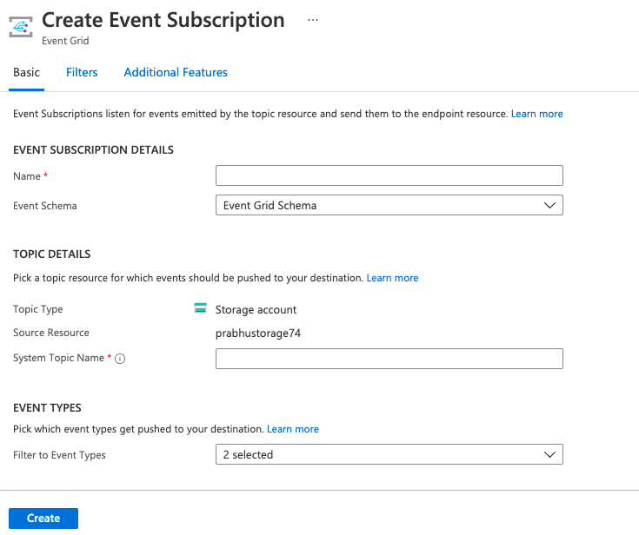

===> PAAS

APP SERVICES - we will create web app then developers will generate the code.
this app will be deployed by the devops team.
web app or app service both are same
app service - to deploy the application
application plan - server to deploy app services
it will act as host to app services , it will provide configuration required to app services
application insight - to monitor the app
configuration - i)application settings - app settings can be transformed from pipeline
ii)database connections

devops role in app service - 1)infrastructure creating
2)deploying code into infra

Deployement of apps
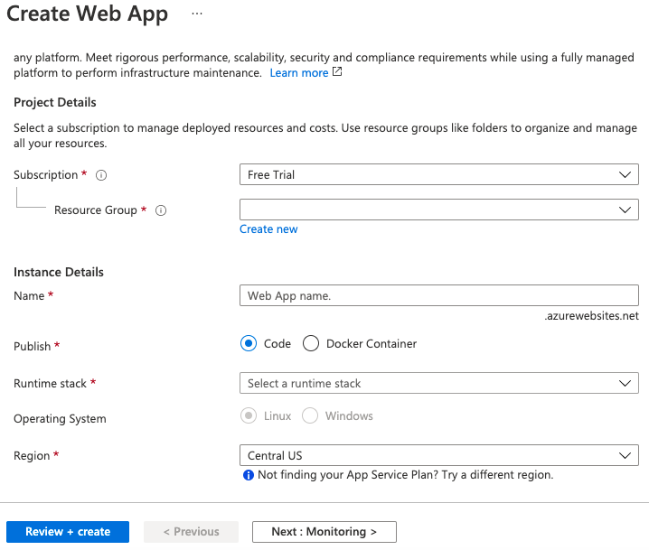
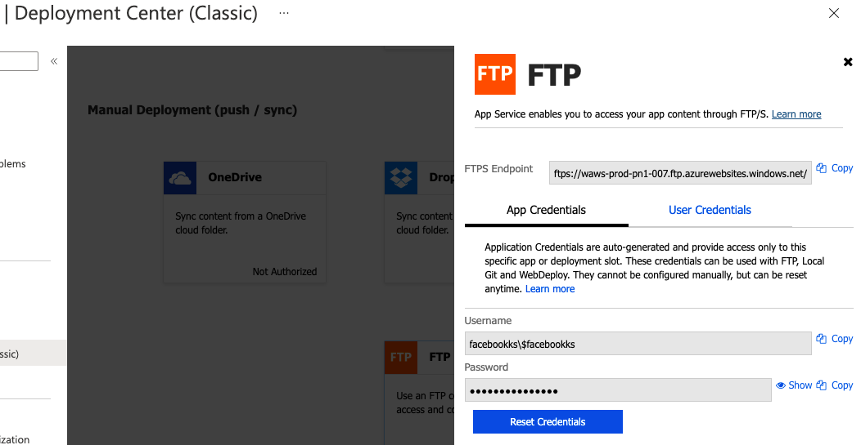
1)winscp —> it is a tool which is used to copy data, applications from on premises server to remote server or vice versa.

in winscp tool, we will enter the endpoint connection and credentials. here FTP is for manual deployment.
to check the app dependencies we will check in configuarations or kudo(web.config)
to override the web.config values we can use configuration.

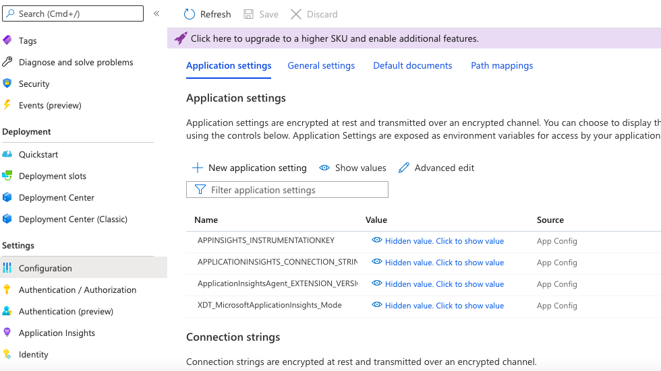
horizontal scaling vs vertical scaling
Horizontal scaling means scaling by adding more machines to your pool of resources (also described as “scaling out”), whereas vertical scaling refers to scaling by adding more power (e.g. CPU, RAM) to an existing machine (also described as “scaling up”).

V - scale up - configuaration can be changed — p1v1 , p2v2
H - scale out - instances can be increase — and also can create rules for max and min instances

2)deployment slots
i) production slot
ii)stage slot
these are used for
i)for zero down time deployments
ii)roll back deployments
first code will be deployed on staging slot , if all good then it will deployed on to production slot by swapping the production to staging
3)vm deployment
i)Create a VM and go to server manager , make it web server by installing IIS service.es
ii)open the IIS console and under sites, select default website
iii)right click on default website and select the source files
1)how to read the connection string from storage account using powershell
2)write a powershell script for updating storage connection string to web app
get-azstorage account
4)azure devote

port numbers
20, 21 | File Transfer Protocol (FTP) | TCP
22 | Secure Shell (SSH) | TCP and UDP
23 | Telnet | TCP
25 | Simple Mail Transfer Protocol (SMTP) | TCP
50, 51 | IPSec
53 | Domain Name System (DNS) | TCP and UDP
67, 68 | Dynamic Host Configuration Protocol (DHCP) | UDP
69 | Trivial File Transfer Protocol (TFTP) | UDP
80 | HyperText Transfer Protocol (HTTP) | TCP
110 | Post Office Protocol (POP3) | TCP
119 | Network News Transport Protocol (NNTP) | TCP
123 | Network Time Protocol (NTP) | UDP
135-139 | NetBIOS | TCP and UDP
143 | Internet Message Access Protocol (IMAP4) | TCP and UDP

161, 162 | Simple Network Management Protocol (SNMP) | TCP and UDP
389 | Lightweight Directory Access Protocol | TCP and UDP
443 | HTTP with Secure Sockets Layer (SSL) | TCP and UDP
989, 990 | FTP over SSL/TLS (implicit mode) | TCP
3389 | Remote Desktop Protocol | TCP and UDP

Active directory

To manage the users globally and to maintain the groups

Auditing
to track everything regarding users.(stored under storage account append blob)

Key Vault - secrets , keys , certificates can be stored
access on key vault can not be inheritated from subscription(even subscription owner can not access key vault)
access on key vault can be given through IAM

Costume Domain - to replace domain name with our own costume domain will use this
A record — A record with ip address
C name - C name and host name
eg- if there url is url123.com then we can map our costume domain prabhu.com on that through costume domains
errors
2xx
3xx
4xx
5xx
ways to connect azure to different tools
1)service principle
2)manage identity
3)AD based authentication

Azure Devops

provides five types of services
i)boards — to create dashboards and to track everything
ii)repos —- storing pieces of code in different branches
iii)pipelines - for ci/cd
CI —- developer commit a code to shared repository on regular basis

or when ever the developer commit the code in repos , we need to compile the code and need to generate required artefacts.

cd - when the artefacts are generated in the build pipe line we need to build insfrastructure. on the top of infrastructure deploy the code

iv)test plan -
v)artefacts - to share and maintain packages

build artefacts
azure artefacts

connections
i)service principle -
ii)managed identity - to connect to any resource , we can generate object identity by enabling system generated option in identity. it will be allow access to connect to particular manage identity generated resource
So to read the secrets , certificate and keys from key vault in application
iii)AAD

branching and merging strategies

branch

A branch is an isolated version of the code that you can work on offline without impacting other developers on your team. ... Commit changes to your branch locally. You can keep track of your commit history locally while you work. Push your changes to the remote repository, in the case of this guide, Azure DevOps

GIT Flow -

i)development branch —- latest code
clone the code to local —>we will add changes —>switch this branch from develop to feature

ii)) release branch —- contains old and new features of code

iii)feature branch — implementing changes on top of a existing code

iv)master branch —- production code is present in master branch (backup of production brßanch)
used for production releases

v)hot fix branch —- code from master branch

all the above branches are flow of GIT process.

sonar tube or sonar cloud is used to vulnerabilities , duplicate codes , minor or major issues.

pushing code from feature to dev branch is called merge request or pull request(PR)

——————production branch——————-

——————hot fix———————

——————— Master branch———————(copy of production code)
pull request
———————-release branch—————-

———————— develop branch —————-
pull request —- sonar qube
—————————- feature branch——————

tortoise git — to send code from local to feature

Release flow

- master branch

a)direct from master to production(production will be frozen called as lock)

b)creating tags on master and moving to production

Note: Both the flows described above fall under “REPO Services”

GIT Commands:

Git init - Used to copy the data from server in to local repository
Git Clone - Copy
Git Add - To add the modifications
Git commit - to commit the modifications in the local repository
Git Push - to push code from local repo to server
Git Pull - to pull code from server to local repo
Git Fetch - to check the changes in the server
Git Stash - The code will be pasted under staging environment
Git config -

Azure work item types

Link:

https://docs.microsoft.com/en-us/azure/devops/boards/work-items/guidance/agile-process-workflow?view=azure-devops

https://docs.microsoft.com/en-us/azure/devops/boards/work-items/guidance/choose-process?view=azure-devops&tabs=basic-process

Types:

- Basic
- Agile
- Scrum
- CMMI

Note: Agile and Scrum are most commonly used in real time

TFVC —- team foundation version control (while creating project )

Agent pools

hosted agents

self hosted agents

difference between agent pool and deployment pool ?????????????

azure —- IAAS and PAAS

Azure devops —— SAAS

branches
repos — pending

Pipelines

its azure service that lets you to build ,test and deploy applications on azure cloud and other supported platforms.

i)platform and language independent
ii)freedom to work with containers
iii)deployment to other cloud vendors
iv)support for open source

Azure Pipelines automatically builds and tests code projects to make them available to others. It works with just about any language or project type. Azure Pipelines combines continuous integration (CI) and continuous delivery (CD) to constantly and consistently test and build your code and ship it to any target.

2 types of pipelines
i) Yaml - stored in the form of yml code. stored in repos. it has multiple stages such as build and release(both fill be performed in single stage)
we can deploy condition based pipelines.
ii)class c - graphical representation.here the build stage and release stages are performed separately.

language build tool

java ——— maven
.net ——— MS build
.net core —— .net
angular js —— NPN

here We have used MS build to compile, build and to generate artefacts of a source code.

creating pipeline

selecting agent

agent is used to build to compile, build and to generate artefacts of a source code.

agent will be created on remote server

class - 23
hosted agents — managed by micro soft. naming convention is azure pipeline

self hosted agent —- installing required softwares

build configurations
i)debug
ii)release

platform — any cpu

Library —- variables values will be stored.

predefined variables — defined by microsoft
pipeline variables — variables used in within the pipeline
variables group— variables used in group of pipelines

Builds

Gated build — after raising a PR to pass code from feature to dev then gated build will run. here we do quality check.

continuous integration — after the PR completed CI will run. Artefacts will generate.

while creating the pipeline, artefacts will be created. these artefacts are used to deploy the code. Along with artefacts , stages are also created.

scheduled build

releases - generated artefacts will be released.

task group - re usable tasks will be grouped together.

deployment groups - here the code is build and deployed there it self. mostly for vm’s.

ARM

Azure resource manager
Works on .Json format
Microsoft owned template

different types templates
i)predefined —- wen we create a any resource through azure portal , template will be created in background , no need to create

ii)costume defines - implemented from the scratch

iii)linked or nested - calling template under another template
all the above three has both main and param templates

ARM template is combination of two templates
i)main - it contains the resources configuration

ii)parameter - if we want to change execution of main template value we use param

Synatx

{

$schema:” “ —-
contentVersion: “1.0.0”
parameters:
{
strname:{
type: string
default value: “prabhu”
}
location:{
type: string
default value: “hyd”

},
Variables:
{

},
Resources:[
type: “ MIcrosoft.stage/storagemanagement”
name: “ [Parameters(“strname”)]”
location: “ [Parameters(“location”)]”
ApiVersrion: “ ”
],
output:{

}

}

parameters —changing values during execution defined under parameters

variables — functions or values that can be used any where in the

Task groups - if we went to re use the multiple tasks in different projects and to reduce the space of pipelines.

Deployment groups - when we want to deploy task on multiple servers. we will create tag based deployments.

to deploy anything on server we need to enable IIS service first.

Libraries — it has Variables groups.

Hashicorp terraform has all the code in it.

file naming convention

- .tf —for all resources
- var.tf ——variable declaration
- tf.var — to define the variables that over rides variables in var.tf file
- default.var —-to override the variables in azure

Video - 40

induction.enquiries@hcl.com

